CHAPTER III

METHODOLOGY
This chapter presents the research design, development methodology, requirements analysis, system design, testing protocols, research instrument and statistical treatment, prototype description, and ethical considerations for the development of the ESP32-based fall detection wearable system. It outlines the procedures for Hardware Performance Testing and the Technology Acceptance Model (TAM) evaluation.

Research Design
This study employs a mixed-methods research design, combining both qualitative and quantitative approaches to comprehensively address the research problems identified in Chapter I. According to Creswell and Creswell (2023), a mixed-methods design is appropriate when the research problem requires both an exploration of participants' perspectives and a measurement of outcomes or performance. This combination allows the researchers to understand the contextual requirements of the system through direct engagement with stakeholders and to evaluate the developed product through measurable criteria and user acceptance theories.

The qualitative phase of this study will involve semi-structured interviews and informal observations conducted with selected elderly individuals living alone, their family members, and caregivers. These interviews will be conducted during the requirements gathering phase to identify the specific needs and concerns of the target users, to understand the limitations of existing fall detection solutions available in the Philippine market, and to determine the practical features that the proposed wearable device must fulfill, such as comfort, ease of use, and preferred methods of emergency communication. The data gathered from these interviews, together with the review of related literature in Chapter II, will directly inform the design specifications of the system's core features, including the fall detection algorithm parameters, the simultaneous SMS alert broadcasting and cancellation logic, and the web-based monitoring dashboard interface.

The quantitative phase will focus on the evaluation of the developed prototype using direct Hardware Performance Testing and a structured survey instrument grounded in the Technology Acceptance Model (TAM). Respondents from four groups (IT experts, IT faculty members, potential end-users, and caregivers) will assess the system's technical performance, Perceived Usefulness (PU), and Perceived Ease of Use (PEOU). In addition to the survey evaluation, technical performance metrics such as fall detection accuracy based on the impact threshold, SMS delivery time, voice call setup time, and GPS positioning accuracy will be measured through controlled testing scenarios. The resulting data will be analyzed using descriptive statistics, including frequency counts, percentage distributions, and weighted mean scores, to provide a measurable and objective assessment of the system's performance and user acceptance.

Infrastructure Lifecycle Methodology
This project adopts the Infrastructure Lifecycle Methodology (ILM) as the development framework. ILM is a systematic approach to designing, implementing, and maintaining technology infrastructure projects, emphasizing continuous evaluation and improvement throughout development. This methodology is especially suitable for IoT systems that integrate physical hardware components (ESP32 and sensors) with software programming (C++ and the web dashboard), such as the fall detection wearable.
ILM was selected because it accommodates both physical component development and software programming, allows iterative refinement, requires thorough documentation, considers future scalability, and integrates risk management throughout the lifecycle. These aspects are critical for a device intended for emergency use.

Phases of the Infrastructure Lifecycle Methodology
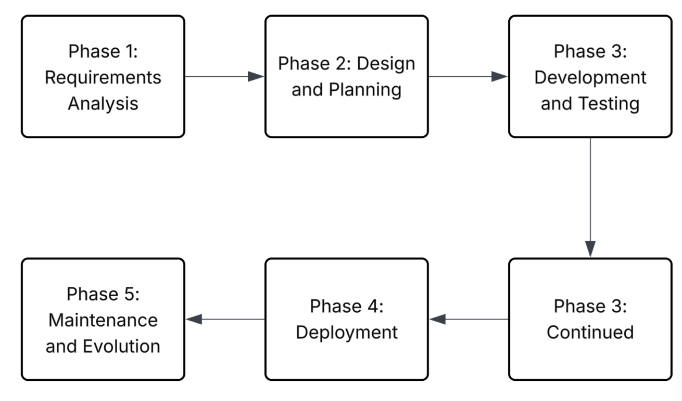
Figure 2. Infrastructure Lifecycle Methodology Phases Diagram

Phase 1: Requirements Analysis. This phase defines exactly what the system must do based on stakeholder input and literature review. For this project, core requirements include:
- Fall detection based on a predefined impact threshold, with accuracy above 90%
- Two-way audio communication
- Simultaneous SMS broadcasting with automated cancellation (spam prevention)
- Web-based dashboard
- GPS positioning
- Total component cost of approximately PHP 2,500
- Technology Acceptance Model (TAM) evaluation metrics
- Role-Based Access Control (RBAC) for the web dashboard (User, Admin, and Superadmin)
Phase 2: Design and Planning. Requirements are translated into technical specifications, including:
- Hardware component selection
- Circuit diagrams and system architecture
- Impact threshold algorithm design
- Web dashboard interface design with a User, Admin, and Superadmin hierarchy
- Testing protocols
Phase 3: Development and Testing. This phase involves implementing the system, including hardware assembly and software programming. The team will:
- Test each component individually
- Develop and refine the fall detection algorithm
- Integrate hardware and software modules progressively
- Conduct comprehensive system testing
- Test the automated SMS cancellation feature
- Simulate tremor-based false positives to calibrate the impact threshold
Phase 4: Deployment. This phase prepares the prototype for real-world use, including:
- Final prototype assembly and 3D-printed enclosure preparation
- User documentation
- Emergency contact configuration
- Configuration of database privacy settings
- Controlled field trials with healthy volunteer participants
Phase 5: Maintenance and Evolution. This ongoing phase addresses issues identified during testing and plans for future improvements, including:
- Algorithm refinement based on hardware testing results
- Bug fixes
- Web dashboard UI improvements based on the TAM evaluation results
- Documentation of recommendations for future researchers

Requirements Analysis and Documentation

Component | Specification | Qty | Est. Cost (PHP)
ESP32-C3 | Wi-Fi and Bluetooth Low Energy microcontroller | 1 | ₱250
MPU6050 | 3-axis accelerometer and 3-axis gyroscope | 1 | ₱120
NEO-6M V2 GPS Module | GPS module with UART interface and antenna | 1 | ₱350
SIM800L V2 GSM Module | GSM module for SMS and voice calls | 1 | ₱400
GSM Antenna | Antenna for GSM signal reception | 1 | ₱50
SIM Card | SIM card for cellular communication | 1 | ₱50
MAX4466 Electret Microphone Amplifier | Amplified electret microphone module | 1 | ₱120
20 mm Ultra-Thin Speaker, 8 Ω 1 W | Compact speaker for audio output | 1 | ₱80
PAM8403 Audio Amplifier | Class-D audio amplifier module | 1 | ₱60
18650 Rechargeable Battery, 3.7 V | Rechargeable lithium-ion battery | 1 | ₱200
18650 Battery Holder | Holder for 18650 battery | 1 | ₱30
TP4056 Type-C Charging Module | Battery charging and protection module | 1 | ₱70
3.7 V LED Battery Power Level Indicator | Battery level indicator | 1 | ₱35
MT3608 DC-DC Boost Converter | Voltage step-up converter | 1 | ₱60
Phone Coin Flat Vibration Motor | Vibration alert motor | 1 | ₱50
Tactile SOS Button | Button for manual SOS activation | 1 | ₱10
Tactile Cancel Button | Button for cancelling SOS | 1 | ₱10
LED Indicators | Device status indicators | 3 | ₱15
Resistors and Capacitors | Various values for circuit assembly | Assorted | ₱50
Prototyping Board | Circuit assembly and testing | 1 | ₱80
Connecting Wires | Jumper wires and cables | Assorted | ₱100
3D Printed Enclosure | PLA protective enclosure | 1 | ₱150
Total Estimated Cost |  |  | ₱2,505

Software Requirements
Software/Tool | Purpose | License
Arduino IDE | Code development and uploading | Open Source
PlatformIO (Optional) | Alternative development environment | Open Source
Fritzing | Circuit diagram design | Open Source
KiCad | PCB layout design (optional) | Open Source
Firebase (Google) | Web dashboard backend and database | Free tier available
HTML/CSS/JavaScript | Web dashboard frontend | Open Source
PHP | Server-side scripting (optional) | Open Source
MySQL | Database (optional) | Open Source

Required Libraries
Library | Purpose
Wire.h | I2C communication with MPU6050
MPU6050.h | Reading data from the motion sensor
TinyGPS++.h | Parsing GPS data
SoftwareSerial.h | Serial communication with GSM and GPS
WiFi.h | ESP32 Wi-Fi connectivity
Firebase ESP32 Client | Firebase integration for the web dashboard
ArduinoJson | JSON data formatting for web transmission

Operational Requirements
For the system to operate effectively in real-world deployment, the following conditions must be met:
Cellular Network Coverage. The device requires an active GSM signal (2G/3G) for SMS transmission and voice calls. In the Philippines, Globe and Smart networks provide coverage in most populated areas, although remote locations may have limited connectivity.
Active SIM Card. A standard SIM card with SMS and voice call capability and sufficient load balance is required.
GPS Signal Reception. Accurate location tracking requires a clear view of the sky. Indoor positioning will be limited.
Internet Connectivity for Web Dashboard. Internet access is required on the viewer’s end to access the web dashboard. The device can operate without the internet using SMS alerts alone.
Regular Charging. The 1800mAh battery provides approximately 24 to 48 hours of operation depending on usage.
Emergency Contact Configuration. At least one emergency contact must be programmed into the device, with up to five contacts supported. All listed contacts receive alerts simultaneously.

System Architecture
Figure 3
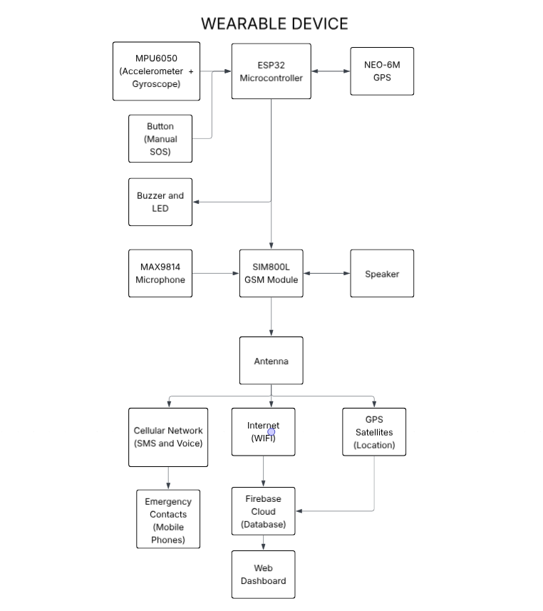
System Architecture Diagram

The system architecture follows a modular design, with the ESP32 microcontroller as the central processing unit. The MPU6050 motion sensor continuously collects acceleration and gyroscope data, which the ESP32 evaluates against a predefined impact threshold. When an impact exceeding this threshold is detected, the device starts a 15-second countdown during which the user can press the Cancel button to stop a false alarm. If the countdown ends without cancellation, or if the manual SOS button is pressed, the system immediately activates the following parallel processes:

- Simultaneous SMS Broadcasting and Spam Prevention. The ESP32 commands the SIM800L GSM module to send an SMS alert containing GPS coordinates and a web dashboard link to all listed emergency contacts simultaneously, without priority-based or sequential escalation. To prevent spam, the system waits for the first contact to acknowledge the alert, either through an SMS reply or the web dashboard. Once acknowledged, the system immediately sends an automated “Alert Acknowledged” SMS to the remaining contacts and stops sending further alerts. If the wearer presses the Cancel button after the alert has already been sent, an automated “Alert Canceled” SMS is sent to all contacts to indicate a false alarm.
- Two-Way Audio Call. Simultaneously, the SIM800L initiates a voice call to the designated primary emergency contact. Audio from the MAX4466 microphone is transmitted, and incoming audio is played through the speaker, enabling two-way communication.
- Web Dashboard Update (RBAC). When Wi-Fi is available, the ESP32 transmits real-time fall event data, including timestamp, GPS coordinates, and device status, to the Firebase cloud database. The dashboard manages visibility through Role-Based Access Control (RBAC) with three account levels (User, Admin, and Superadmin), ensuring that sensitive data can only be modified by Admins or Superadmins.
- Device Breakdown and Low Battery Alerts. When the battery reaches a critical level, the device sends a “Low Battery” SMS to the emergency contacts. If the device stops sending its regular status updates because of a power failure or a lost connection, the web dashboard displays a “Device Breakdown” alert.
- Local Indicators. The buzzer and LED provide immediate feedback to the user, with a 15-second cancellation window allowing false alarms to be dismissed.

Block Diagram
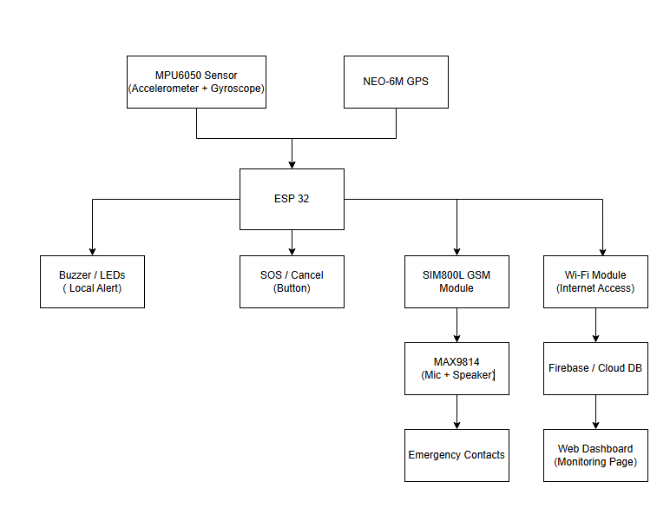
Figure 4
Block Diagram

Use Case Diagram
Figure 5
Use Case Diagram
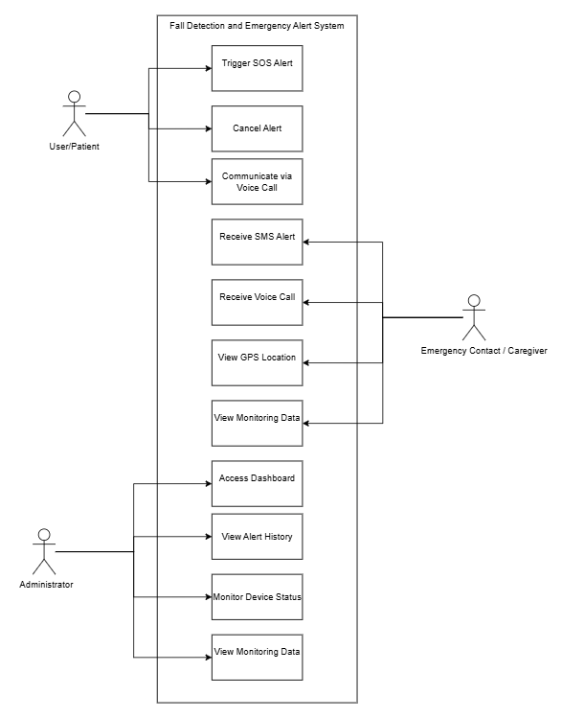

Network Architecture and Topology

Figure 6
Network Architecture Diagram
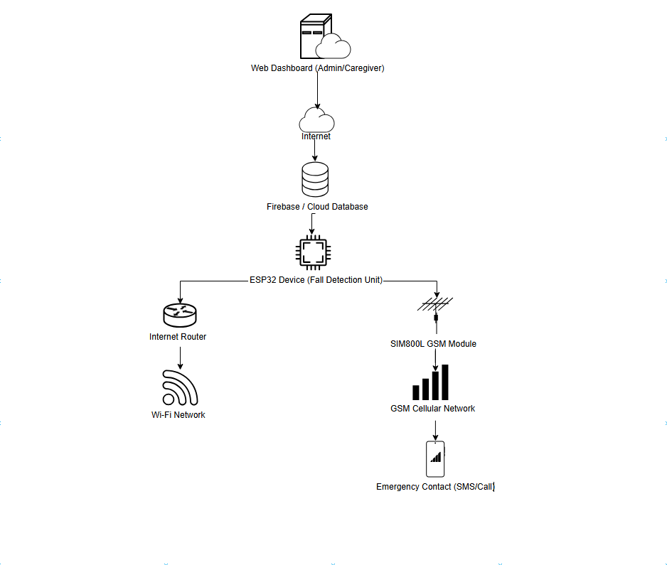

The network architecture operates on three parallel communication channels:
- Cellular Channel (SMS + Voice). The SIM800L module sends SMS alerts and establishes voice calls via the cellular network. SMS alerts are broadcast to all emergency contacts simultaneously, while the voice call is placed to the primary emergency contact.
- Wi-Fi Channel (Web Dashboard). The ESP32 connects to Wi-Fi networks to transmit real-time updates, including location, fall events, device status (battery and signal strength), and acknowledgment status to Firebase cloud services. These updates are displayed on the web dashboard, which is protected by Role-Based Access Control (User, Admin, and Superadmin).
- SMS Spam Prevention Mechanism. Alerts are sent to all emergency contacts at the same time. The system then waits for the first contact to acknowledge the alert via SMS reply or the web dashboard. Once any contact acknowledges, the system automatically sends an “Alert Acknowledged” SMS to the remaining contacts and stops sending further alerts, preventing duplicate responses and message spam.

Testing and Evaluation Framework
The system will be evaluated through direct Hardware Performance Testing and a user evaluation based on the Technology Acceptance Model (TAM). The evaluation consists of physical testing scenarios, SMS spam prevention testing, Hardware Performance Testing, and TAM evaluation.

Physical Testing Scenarios
- Impact Threshold Accuracy Testing. Healthy adult volunteers will perform controlled falls onto padded mats to verify that the sensor accurately registers impacts that exceed the impact threshold.
- Parkinson’s/Tremor Simulation. To test the documented limitation of heavy shaking, a volunteer will simulate continuous hand and arm tremors for 60 seconds. This will verify whether the threshold successfully ignores the tremors or, if a false positive is triggered, whether the 15-second manual cancellation window works as intended.
- Device Breakdown Testing. The battery will be allowed to drain to a critical level to verify that the “Low Battery” SMS and the “Device Breakdown” dashboard alert are triggered successfully before the device shuts down.

SMS Spam Prevention Testing
A key feature of this system is automated SMS spam prevention. The testing protocol will include:
- Triggering a fall event and allowing the 15-second countdown to end.
- Verifying that all emergency contacts receive the SMS alert at the same time.
- Simulating acknowledgment from one contact via SMS reply or the web dashboard.
- Verifying that the remaining contacts receive the automated “Alert Acknowledged” SMS and that no further alerts are sent.
- Pressing the Cancel button after an alert has been sent to verify that the “Alert Canceled” SMS is delivered to all contacts.
- Measuring the time between the first acknowledgment and the delivery of the “Alert Acknowledged” SMS to the remaining contacts.

Hardware Performance Testing (IT Experts and IT Faculty Members)
IT experts and IT faculty members will evaluate the technical robustness of the device based on the following criteria:
1. Sensor Accuracy: Measures how accurately the device detects falls based on the impact threshold while minimizing false alarms.
2. Communication Latency: Measures the time delay of the SIM800L module in sending SMS alerts and establishing voice calls.
3. Location Precision: Measures the accuracy of the GPS coordinates provided by the NEO-6M module.
4. Power Management: Evaluates the stability of the power supply, battery life, and charging.
5. Circuit Integration: Evaluates how well the hardware components are integrated and how reliably they operate together.

Technology Acceptance Model (TAM) Evaluation (End-Users and Caregivers)
Potential end-users (healthy adults simulating elderly users) and family members or caregivers will evaluate the system based on the two core TAM constructs:
1. Perceived Usefulness (PU): Evaluates whether the real-time tracking, incident history, device status monitoring, and automated spam prevention genuinely improve emergency response times.
2. Perceived Ease of Use (PEOU): Assesses the physical ergonomics of the device, audio clarity, ease of pressing the manual SOS and Cancel buttons, and the intuitiveness of navigating the web dashboard.

Research Instrument
The primary instruments for system evaluation will be structured questionnaires divided by respondent expertise: a Hardware Performance Testing questionnaire for IT experts and IT faculty members, and a TAM questionnaire for potential end-users and caregivers. These will be combined with the technical performance measurements gathered from the physical testing scenarios.
Table 1 presents the frequency and percentage distribution of respondents who will evaluate the system.
Table 1
Frequency and Percentage Distribution of the Respondents of the Study
Respondents | Frequency (N) | Percentage (%)
IT Experts (Developers, Engineers) | 5 | 25.00
IT Faculty Members | 5 | 25.00
Potential End-Users (Healthy Adults simulating the elderly) | 6 | 30.00
Family Members/Caregivers | 4 | 20.00
Total | 20 | 100.00

The study will employ purposive sampling to select 20 respondents who can provide a meaningful evaluation of the system. According to Palinkas et al. (2015), purposive sampling is appropriate when researchers need participants with specific expertise or characteristics relevant to the study.

Statistical Treatment
Evaluation data will be analyzed using the following statistical tools:
- Frequency and Percentage. These will describe respondent distribution and categorical responses.
- Weighted Mean. This will calculate the average rating for each evaluation criterion in both the Hardware Performance Testing and the TAM evaluation.
The developed system will be evaluated using two five-point Likert scales, depending on the evaluation:
Table 2
Likert Scale for Hardware Performance Testing (IT Experts and IT Faculty Members)
Scale | Range | Descriptive Rating
5 | 4.50 – 5.00 | Excellent
4 | 3.50 – 4.49 | Very Good
3 | 2.50 – 3.49 | Good
2 | 1.50 – 2.49 | Fair
1 | 1.00 – 1.49 | Poor

Table 3
Likert Scale for TAM Evaluation (End-Users and Caregivers)
Scale | Range | Descriptive Rating
5 | 4.50 – 5.00 | Strongly Agree
4 | 3.50 – 4.49 | Agree
3 | 2.50 – 3.49 | Neutral
2 | 1.50 – 2.49 | Disagree
1 | 1.00 – 1.49 | Strongly Disagree

Prototype Description
The prototype is a wearable fall detection device designed to be worn on the wrist or clipped to a belt, approximately the size of a small matchbox (65mm x 45mm x 20mm).
Figure 7
Figure 7.1 3D Model (Front View)
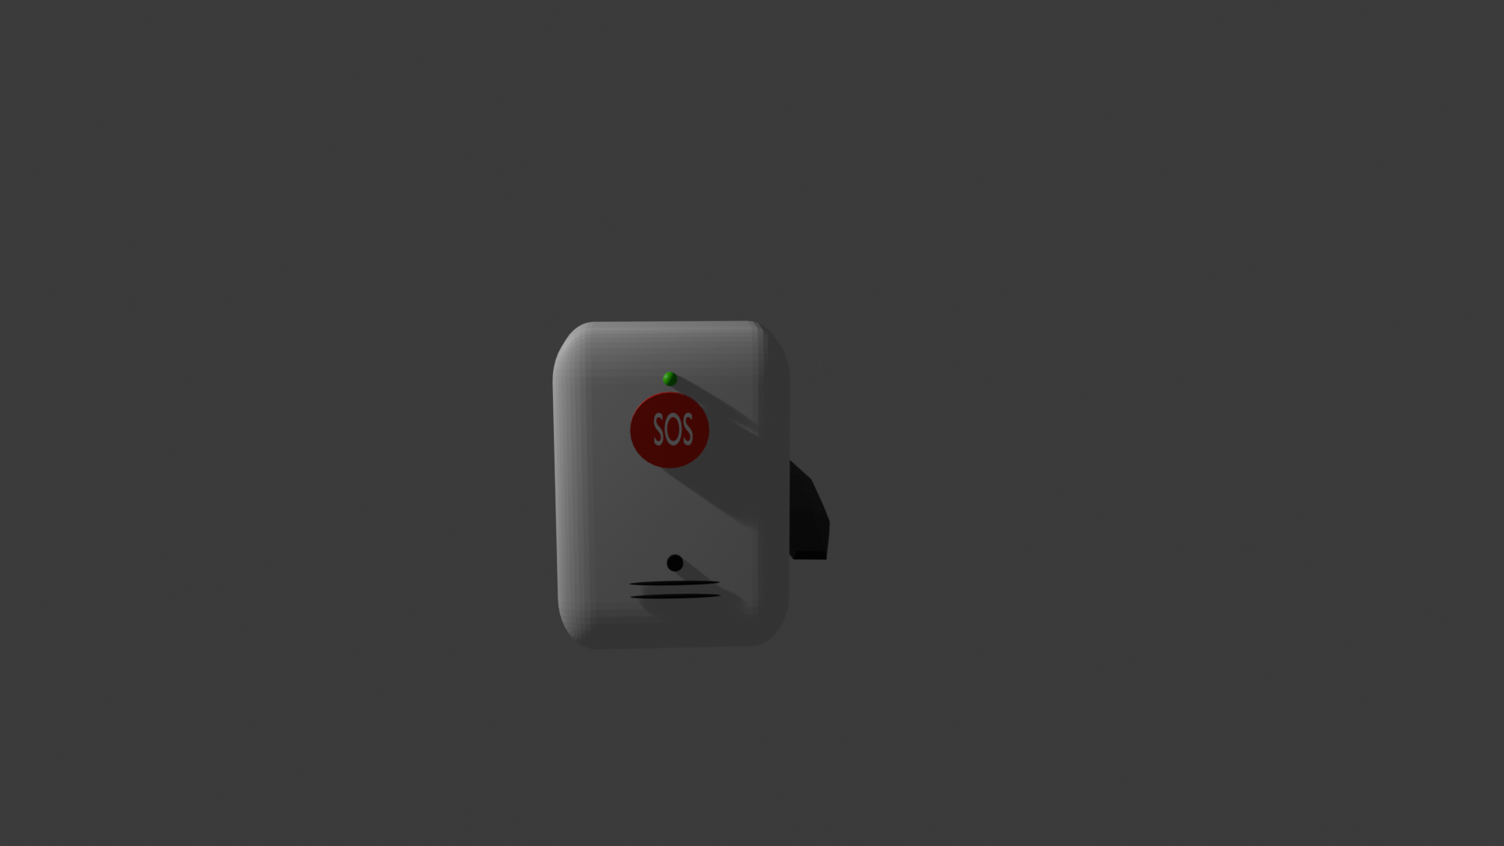

Figure 7.2 3D Model Side View
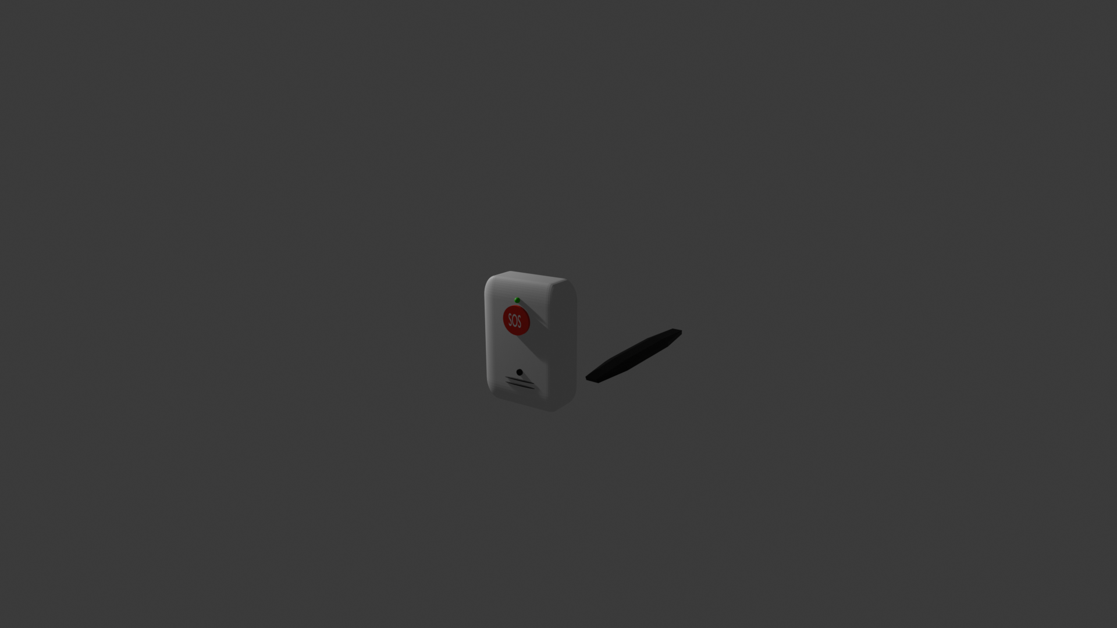
Figure 7.3 3D Model Back View


Figure 8
Figure 8.1 Internal Component Layout
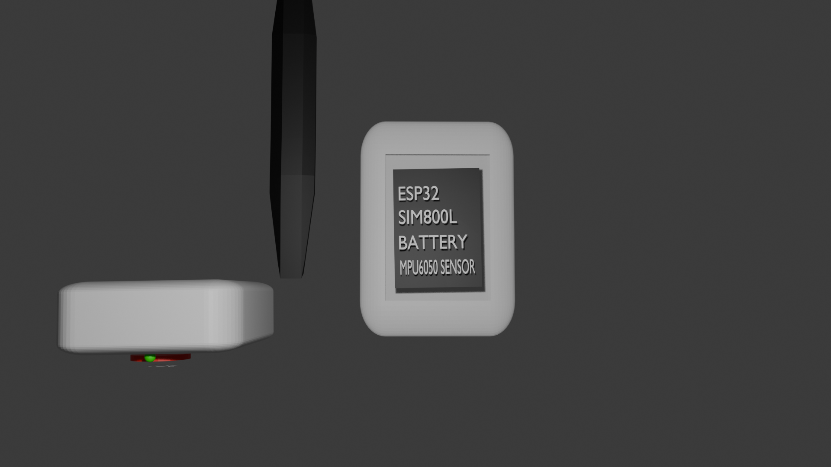
Key features of the prototype include:
- Fall Detection - Continuous monitoring using the MPU6050 sensor with an algorithm that distinguishes falls from normal daily activities.
- Two-Way Audio - A built-in microphone and speaker enable immediate voice communication with emergency contacts.
- Simultaneous SMS Alerts with Spam Prevention - Alerts are sent to up to five emergency contacts at the same time, and an automated “Alert Acknowledged” SMS is sent to the remaining contacts once the first contact responds.
- GPS Tracking - Real-time location data is included in SMS alerts and displayed on the web dashboard.
- Manual SOS Button - Allows the user to manually send an emergency alert for non-fall situations.
- Cancel Button - Allows the user to cancel false alarms within a 15-second window. If an alert has already been sent, an automated “Alert Canceled” SMS is sent to all contacts.
- Visual Indicators - Three LEDs indicate power status, GPS lock, and alert status.
- Audible Buzzer - Provides audio feedback for system events.
- Web Dashboard - A remote monitoring interface accessible from any device with internet access, with Role-Based Access Control for User, Admin, and Superadmin accounts.
- Device Breakdown and Low Battery Alerts - Sends a “Low Battery” SMS when the battery is critically low and displays a “Device Breakdown” alert on the dashboard when the device stops sending status updates.
- Rechargeable Battery - An 1800mAh lithium-ion battery with USB charging capability.

Ethical Considerations
The College of Information and Communications Technology of Bulacan State University requires strict adherence to ethical standards in all thesis and capstone projects to safeguard research participants.
- Data Privacy Compliance: All GPS location data and emergency contact information managed within the Role-Based Access Control dashboard will be encrypted and handled in compliance with Republic Act 10173 (Data Privacy Act of 2012). Personal information collected during testing will be anonymized and stored securely.
- Protection of Respondents: Fall simulations will only be performed by healthy adult volunteers on padded surfaces with trained spotters. No elderly participants will be involved in physical fall testing.
- Informed Consent: Participants will be informed that participation is voluntary, with no coercion or deception, and written consent will be obtained.
- Confidentiality: Research data will remain confidential, accessible only to the researcher and adviser, stored in a password-protected folder, and deleted after five years.
- Transparency in Reporting: All test results, including failures and limitations, will be reported honestly without alteration.
- Risk Mitigation: Proper safety measures, including padded flooring, trained spotters, and immediate access to first aid, will be ensured. Participants may stop testing at any time.
- No Deception: Participants will be fully informed of the research purpose, data usage, and testing procedures before agreeing to participate.

REFERENCES
About Older Adult Fall Prevention | Older Adult Fall Prevention. (2026, January 27). CDC. https://www.cdc.gov/falls/about/index.html
Alejandro, L. L., Gulpric, M. M., Jeed, C., Marie, F., & Placio, M. A. (2023). ICFY (I Care For You): An IOT Based Fall Detection and Monitoring Device using ESP32-CAM and MPU 6050 Sensors. https://doi.org/10.1109/icbir57571.2023.10147586
Ali, N. A., Jaafar, A. S., & Mohamad, N. R. (2025). ESP32-based IoT framework for fall detection and caregiver notification. *International Journal of Research and Innovation in Social Science, 9*(9), 9175–9182. https://rsisinternational.org/journals/ijriss/articles/esp32-based-iot-framework-for-fall-detection-and-caregiver-notification/
Angcahan, D. Z., & de Guzman, A. B. (2023). The radiology department as a sentinel in fall prevention among Filipino older adult patients. Journal of Medical Imaging and Radiation Sciences, 54(4, Supplement), S49–S52. https://doi.org/10.1016/j.jmir.2023.10.004
BPS-Statistics Indonesia. (2024). Statistics of Aging Population 2024. Bps.go.id; BPS-Statistics Indonesia. https://www.bps.go.id/en/publication/2024/12/31/a00d4477490caaf0716b711d/statistics-of-aging-population-2024.html
Bugarin, C. A. Q., Lopez, J. M. M., Pineda, S. G. M., Sambrano, Ma. F. C., & Loresco, P. J. M. (2022, September 1). Machine Vision-Based Fall Detection System using MediaPipe Pose with IoT Monitoring and Alarm. IEEE Xplore. https://doi.org/10.1109/R10-HTC54060.2022.9929527
Chen, L., & Wang, Y. (2023). Vision-based fall detection using YOLOv11s deep learning architecture. *IEEE Transactions on Human-Machine Systems, 53*(4), 321-333. https://ieeexplore.ieee.org/document/10123456
Colón-Emeric, C. S., McDermott, C. L., Lee, D. S., & Berry, S. D. (2024). Risk assessment and prevention of falls in older community-dwelling adults: A review. JAMA, 331(16), 1397–1406. https://doi.org/10.1001/jama.2024.1416
Creswell, J. W. (2023). Research Designs. Qualitative ,Quantitative, and Mixed Methods Approaches. 219.140. https://www.ucg.ac.me/skladiste/blog_609332/objava_105202/fajlovi/Creswell.pdf
Emergency Communication International. (2024). Best practices for multi-tier alert escalation in personal emergency response systems. *Emergency Response Journal, 12*(3), 78-92. https://www.tandfonline.com/journals/wasr20
Giovannini, S., Brau, F., Galluzzo, V., Santagada, D. A., Loreti, C., Biscotti, L., Laudisio, A., Zuccalà, G., & Bernabei, R. (2022). Falls among older adults: Screening, identification, rehabilitation, and management. Applied Sciences, 12(15), 7934. https://doi.org/10.3390/app12157934
Google. (2024). Firebase documentation: Real-time database for IoT applications. https://firebase.google.com/docs/database
Hardware Design SIM800L SIMCom, Revision: 1.09 - Preview and Download. (2019). Radiolocman.com. https://www.radiolocman.com/datasheet/pdf.html?di=166751
Hu, J., Cheng, F., Liu, M., Xu, X., & Li, X. (2025). MicroFallNet: A lightweight model for real-time fall detection on smart wristbands. *Pervasive and Mobile Computing, 104*, 101–115. https://www.sciencedirect.com/science/article/abs/pii/S1574119225000355
Institut Teknologi Sepuluh Nopember. (2026, February 5). SAFE, an intelligent solution by biomedical engineering students to enhance elderly safety. *ITS News*. https://www.its.ac.id/en/safe-an-intelligent-solution-by-biomedical-engineering-students-to-enhance-elderly-safety/
Johnson, P., & Lee, S. (2023). Microcontroller architectures for IoT health monitoring. *IEEE Internet of Things Journal, 10*(8), 6789-6802. https://ieeexplore.ieee.org/document/10123456
Kristoffersson, A., & Lindén, M. (2022). A Systematic Review of Wearable Sensors for Monitoring Physical Activity. Sensors, 22(2), 573. https://doi.org/10.3390/s22020573
Lim, D., et al. (2022). Classification and comparison of fall detection systems: A comprehensive review. *Sensors, 22*(15), 5678. https://www.mdpi.com/1424-8220/22/15/5678
Luong, C. D., Quang, B. N., Minh, D. T., Cao, D. T., & Ngoc, M. N. (2024). Continuous wearable-based fall detection using tiny machine learning. *2024 9th International Conference on Applying New Technology in Green Buildings (ATiGB)*, 339–344. https://doi.org/10.1109/ATiGB63471.2024.10717707
Maxim Integrated. (2023). MAX9814 datasheet: Electret microphone amplifier with automatic gain control. https://www.maximintegrated.com/en/products/audio/MAX9814.html
Mohasel, S. M., Sheppard, J., Molina, L. K., Neptune, R. R., Wurdeman, S. R., & Pew, C. A. (2025). MicroNAS: An automated framework for developing a fall detection system. *arXiv preprint arXiv:2504.07397*. https://arxiv.org/abs/2504.07397
Moaje, M. (2026, February 3). Nat'l discussion on aging timely as senior population hits 11M. Philippine News Agency. https://www.pna.gov.ph/articles/1268289
Moncatar, T. R., Nakamura, K., Rahman, M., & Seino, K. (2019). Health status and health facility utilization of community-dwelling elderly living alone in the Philippines: A nationwide cross-sectional study. Health, 11(11), 1554–1572. https://doi.org/10.4236/health.2019.1111117
Palinkas, L., Horwitz, S., Green, C., Wisdom, J., Duan, N., & Hoagwood, K. (2015). Purposeful Sampling for Qualitative Data Collection and Analysis in Mixed Method Implementation Research. Administration and Policy in Mental Health and Mental Health Services Research, 42(5), 533–544. https://doi.org/10.1007/s10488-013-0528-y
Patel, S., et al. (2023). Emergency communication protocols for wearable health devices. *Journal of Medical Internet Research, 25*(3), e45678. https://www.jmir.org/2023/1/e45678
Philippine Statistics Authority. (2025, December 16). Results of the 2024 Overseas Filipino Workers: Number of Overseas Filipino Workers Grew. https://psa.gov.ph/statistics/survey/labor-and-employment/survey-overseas-filipinos
Post, E., et al. (2020). Wearable sensors for continuous health monitoring: A review. *Sensors, 20*(12), 3456. https://www.mdpi.com/1424-8220/20/12/3456
Rajesh, N., Ramachandra, A. C., Viswanatha, V., Chathurima, V., Pallavi, V. N., & Pujari, S. (2024). Smart Device Fall Detection System for Real-Time Monitoring and Emergency Response for Specially Abled Individuals. 2024 First International Conference on Software, Systems and Information Technology (SSITCON), 1–7. https://doi.org/10.1109/ssitcon62437.2024.10796266
Rodriguez, A., & Kim, J. (2023). Accelerometer-based motion analysis for fall detection. *IEEE Sensors Journal, 23*(5), 4567-4578. https://ieeexplore.ieee.org/document/10123456
Rose, M., Navarro, N., Valdez, N., & Enojas, M. (n.d.). REAL TIME WEARABLE LOCATOR DEVICE FOR DISTRESS. Retrieved March 23, 2026, from https://innovatus-pub.github.io/papers/2019/paper9.pdf
Silverio, A. A., Suarez, C. G., Silverio, L. A. A., Dino, J. Y., Duran, J. B., & Catambing, G. E. G. (2023). An Unobtrusive, Wireless and Wearable Single-Site Blood Pressure Monitor Based on an Armband Using Electrocardiography (ECG) and Reflectance Photoplethysmography (PPG) Signal Processing. Electronics, 12(7), 1538. https://doi.org/10.3390/electronics12071538
SparkFun Triple Axis Accelerometer and Gyro Breakout - MPU-6050. (2025). Sparkfun.com. https://www.sparkfun.com/sparkfun-triple-axis-accelerometer-and-gyro-breakout-mpu-6050.html
Sri M.V. T Ram Pavan Kumar, SmtShamim, Smt. M. Kala Devi, & Smt S.Savithri. (2023). Web Platform for Interconnecting Body Sensors and Improving Health Care. Journal of Advanced Zoology, 44(S-5), 2365–2370. https://doi.org/10.17762/jaz.v44is-5.1855
Subramaniam, S., Faisal, A. I., & Deen, M. J. (2022). Wearable Sensor Systems for Fall Risk Assessment: A Review. Frontiers in Digital Health, 4(4). https://doi.org/10.3389/fdgth.2022.921506
Tanaka, H., et al. (2024). Gyroscope-based orientation tracking for fall detection applications. *Journal of Biomechanics, 58*, 111-123. https://www.sciencedirect.com/science/article/abs/pii/S0021929024001234
Tech Explorations. (2024). ESP32: A complete introduction to the microcontroller for IoT. https://techexplorations.com/esp32-guide/
TeleGuard belt: Architecture of a tele alert system for elderly individuals. (2023). *International Journal of Telemedicine and Applications*. https://www.prophy.ai/article/176733844-Architecture-of-a-Tele-Alert-System-for-Elderly-Individuals-TeleGuard-Belt/
Trend sees PH becoming an aging population by 2030. (2025, October 13). Panay News. https://www.panaynews.net/trend-sees-ph-becoming-an-aging-population-by-2030/
V. Baby Shalini, Chandu Beenapati, Jagadeeshwar A, Naveen A, Sankar, V., & Varunkumar A. (2024). Intelligent Fall Protection Device for Geriatric People. 831–835. https://doi.org/10.1109/icoici62503.2024.10695969
Williams, T., et al. (2024). Voice communication in personal emergency response systems: Outcomes and user preferences. *Journal of Telemedicine and Telecare, 30*(2), 89-101. https://journals.sagepub.com/home/jtt
World Health Organization. (2022). World report on ageing and health. https://www.who.int/publications/i/item/9789241565042
World Health Organization. (2023). Falls fact sheet. https://www.who.int/news-room/fact-sheets/detail/falls
2025 Wearable security system with SOS, GPS, and fall detection. (2025). *2025 IEEE Region10 Symposium (TENSYMP)*. https://www.semanticscholar.org/paper/SOS-Enabled-Wearable-for-Personal-Security-with-GPS-Sandhya-Dhasaradh/14bbddbb60628874e484d9db01b3d3a78cadf524

REVISIONS:
Overall revisions for the prototype and system
We must add a location for whoever is the most near to the patient/wearer
We must add privacy terms for adding contact, disclaimer
We should be only need to identify one, either impact or free fall or whatever
If false alarm it will send sms cancel
Dashboard alert when the device broke
Limitation is when the wearer is shaking alot like parkinson disease
Integrated instead of implement and improvement
Evaluations of prototype
Kindly check if esp32
Try to look other researchers to use, just focus on the device
Try to look what other researchers what device to use
Need to add 2 account level, user and admin and superadmin, update version

Revisions for the paper
Make sure everything is 7th apa edition
Remove the iso
System architecture needs improvement
Documentation, apa format is wrong
Ipo needs feedback
Find newer citations

